Up to $2,000 Savings Per Stateroom

WITH COMPLIMENTARY UPGRADE
PLUS $100 ONBOARD CREDIT PER STATEROOM
OUR GIFT TO YOU
Holiday Triple Savings

CRUISE ITINERARY | SHIP NAME | 2019  EMBARKATION DATES | BALCONY CRUISE ONLY PP | SPECIAL BALCONY CRUISE PP | OPTIONAL  LAND PROGRAMS
Romantic Danube  7-nt Vilshofen - Budapest cruise | AmaLea AmaMagna | Dec 27  Dec 29 | $4,498  $5,098 | $3,498  $4,098 | 2 nights Munich or 3 nights Prague
Melodies of the Danube  7-nt Budapest - Vilshofen cruise | AmaSonata AmaViola | Dec 27  Dec 29 | $4,498  $4,498 | $3,498  $3,498 | - nights Budapest  - nights Prague
Enchanting Rhine  7-nt Basel - Amsterdam cruise | AmaSerena AmaKristina | Dec 29  Dec 30 | $4,498  $4,498 | $3,498  $3,498 | 2 nights Zurich & 2 nights Lucerne
Iconic Christmas Markets  7-nt Budapest - Nuremberg cruise or reverse | AmaLea AmaViola AmaLea AmaSonata | Nov 22  Nov 24  Dec 13  Dec 20 | $4,398  $4,498  $4,498  $4,498 | $3,398  $3,498  $3,498  $3,498 | 3 nights Budapest  3 nights Prague
Christmas Markets on the Danube 7-nt Budapest - Vilshofen cruise or reverse | AmaMagna AmaLea | Dec 1, 15, 22  Dec 20 | $5,098  $4,498 | $4,098  $3,498 | - nights Budapest  - nights Prague
Magical Christmas Markets  7-nt Nuremberg - Vienna cruise or reverse | AmaCerto | Dec 15, 22, 29 | $4,498 | $3,498 | 3 nights Prague  2 nights Vienna
Christmas Markets on the Rhine 7-nt Amsterdam - Basel cruise or reverse | AmaStella AmaSerena AmaKristina AmaPrima AmaMora | Nov 24; Dec 8, 15, 22  Nov 24; Dec 1, 8, 15, 22  Nov 25; Dec 2, 9, 16, 23  Nov 30; Dec 7, 14, 21  Dec 9, 16, 23 | $4,498  $4,498  $4,498  $4,498  $4,498 | $3,498  $3,498  $3,498  $3,498  $3,498 | 2 nights Amsterdam 2 nights Lucerne & 2 nights Zurich

THE HIGHEST RATED RIVER CRUISE SHIPS

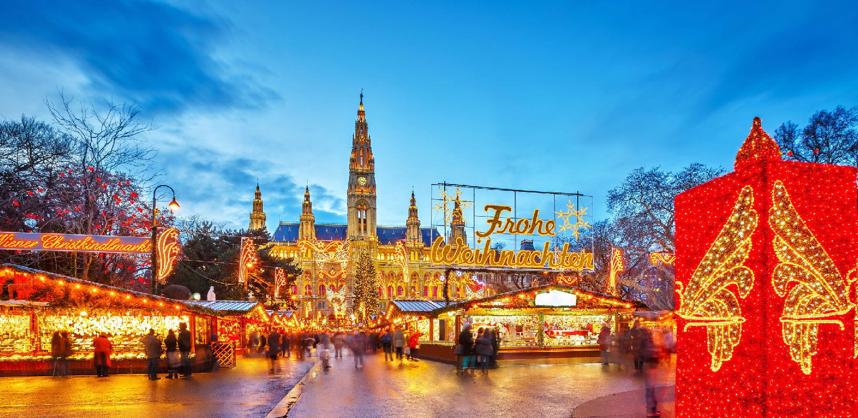
Contact Affordable Cruise Tours and Travel today
www.affordablecruisetoursandtravel.com
(865) 453-0788
Terms & Conditions: Most Christmas markets open during the last week of November until approximately Dec. 22. Check with each country’s tourist office for more information. All rates are per person in USD for cruise only, based on double occupancy in a BB category stateroom (AB category for AmaMagna) unless stated otherwise. Onboard credit of $100 per stateroom ($50 per person) is based on double occupancy in USD and can be applied towards all onboard purchases. Promotional rates are valid on select departure for new bookings only made from June 25 – August 31, 2019. Savings are per stateroom, based on double occupancy. Complimentary upgrades applicable to categories BB – AB (AB – SB for AmaMagna); applies to one category upgrade, based on availability. Offers are combinable with AmaWaterways’ Past Passenger Privilege Program and Future Cruise Benefit Program. Offers are not combinable with any other promotions, limited to availability, capacity controlled and subject to change/termination without notice. Port charges, optional land programs, airfares and gratuities are additional. Up to 5% Bonus Commission is applicable to cruise only, capped based on agency standard commission; cannot be combined with other enhanced bonus commission programs/offers; and not applicable to tour operators or groups. Other restrictions apply. Registration as a seller of travel does not constitute approval by the State of California. CST#2065452-40. V19JUN27SI

